Do Disordered Proteins Dream of Unruly Order? – Dimensionality Reduction Has the Answer!

Interim Report - Summer 2023
Arya Jafari - 1008214111
Supervisor: Dr. Claudiu Gradinaru

Introduction
Intrinsically disordered proteins (IDPs) are proteins which lack the well-defined structure prescribed in the lock-and-key model of traditional proteins [1][2]. The flexible structure of IDPs allows for binding to a wide range of targets making them prevalent in signaling and regulatory pathways [2].
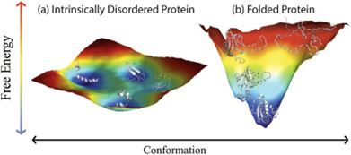
Figure 1: Example illustration of energy landscapes. (a) The energy landscape of an intrinsically disordered protein. (b) The energy landscape of a natively folded protein. The landscape of the natively folded protein has a deep energy well corresponding to the unique conformation it typically takes under standard biological conditions. The IDP landscape has a range of shallow dips in its energy landscape which it can escape from easily, corresponding to distinct stable conformations it might rapidly interchange between [3]
The high conformational irregularity of IDPs renders a single structure description insufficient. Instead, they are represented through ensembles of conformations – sets of potentially hundreds of possible structures they rapidly interconvert between. Elements of ensembles typically have attached weights which are generated according to the correspondence of back calculated measurements to experimental ones [4].
Dimensionality reduction (DR) techniques are a family of algorithms designed with the intent of representing data in the fewer parameters, doing so through mapping to and from a lower dimensional subspace [5]. At a high level, DR discards the degrees of freedom not witnessed by a given set of data and represents it in only essential information – the underlying trends the data takes.
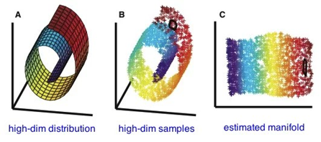

Figure 2: Demonstration of dimensionality reduction. A complex 3-dimensional roll is reduced to a 2-dimensional square.[6]

Due to the high entropy associated with their structure, the function of a given IDP is difficult, if not impossible to determine from ensembles alone. Computational DR methods applied to the space of conformations have potential in simplifying the complex problem to its essentials, removing from consideration the irrelevant fluctuations in structure through reduction to a space of purely functional parameters.

Methods
Protein Systems
Data available for analysis includes molecular dynamics (MD) simulations of sic1 provided by the DE Shaw lab [9] as well as concatenated MD simulations of the open-closed transition of Adenylate kinase (ADK) available from [8]. Statically (FastFloppyTail) generated ensembles of NP-4EBP2 and 5P-4EBP2 are available from our own lab as well as TraDES[12] generated ensembles of sic1, and drkNSH3 (this ensemble generates the protein in varying degrees of foldedness). Additionally, random coil ensembles of NP-4EBP2 serve as control data sets.
A staggered selection of an MD (Molecular Dynamics) trajectory involves choosing conformers at frames based on a modulus operation applied to frame numbers. The modulus number corresponds to a selection time interval, which is dependent on the MD simulation's time step.
For instance, given simulations with time steps of 0.18 ns, it's possible to select conformers at every frame whose number is divisible by 4. In this case, the selection time interval would be 4 * 0.18 = 0.72 ns. These systems were chosen to survey the different degrees of disorder in protein, from natively folded to IDP.

Representation
Conformers were represented using their pairwise inter-residue distance vectors. This vector is the list of distances between every alpha carbon in the protein; thus, a protein of N residues has inter-residue vectors of length N*(N-1)/2.
DR techniques require a metric function on the representation space, in our case the space of inter-residue distances. In this study we utilized the Euclidean metric on this space for all techniques where one was required. We note that while using this metric, residues that are farther apart will have a greater effect on the distance between points than ones that closer together (I.E., residues 20 and 70 will be farther apart on average than 30 and 35 and have a larger effect on the distance). To account for this the data was component-wise standardized: the k-th entry in a specific the inter-residue distance vector, which may correspond to the distance between the i-th and j-th residues is standardized through subtracting the average distance between the i-th and j-th and divided by the standard deviation of the same.
In many places the density of points is graphed as a heat, this value was determined using the scipy.stats.kde object

Techniques
The study employed several dimensionality reduction (DR) techniques, namely PCA, diffusion maps, and tSNE. These methods were chosen to represent varying degrees of non-linearity and were used as a sample to assess the suitability of techniques with similar linearity characteristics.

Principal Component Analysis (PCA)
PCA, a linear DR technique, operates by iteratively selecting orthogonal vectors in the representation space to maximize the variance of data projected onto its span. Data is transformed into a latent space through projection onto the vector space defined by the orthogonal basis. In this context, for a reduced data point X, its i-th coordinate (Y_i ) is calculated as:
Y_i = dot(PCA_i, X)
Where PCA_i represents the i-th PCA component, and Y is the vector in the space. Notably, PCA does not involve tuning parameters. The implementation utilized the sklearn.decomposition.PCA module.

Diffusion Maps
Diffusion maps, a non-linear technique, approximate geodesics on manifolds by constructing paths between data points and leveraging these geodesics to build a manifold representation. Specifically, geodesics are established through diffusion across graph vertices.
This method involves three tunable parameters: epsilon (ε), K, and alpha (α). ε serves as a cutoff value; if the distance between two points is below ε, they are considered neighbors, and the metric determines their distance directly. If the distance exceeds ε, paths are used to compute the distance. K, an integer associated with ε, balances the algorithm's faithfulness to ε against computational cost. K restricts the number of neighboring points to K, even if more points lie within ε of a given point. α normalizes point weights, with values less than one emphasizing larger scale features. [10]
The implementation derived from the pydiffmap.diffusion_map module.

t-Distributed Stochastic Neighbor Embedding (tSNE)
tSNE, a non-linear DR technique, employs probability distributions to determine point proximity and estimate distances, subsequently constructing a manifold representation. The tunable parameters for tSNE include the number of components, perplexity, learning rate, and number of iterations.
Unlike PCA and diffusion maps, tSNE results depend on the latent space dimension to which the data is reduced. This dimension must be determined and refined based on the dataset. Perplexity, akin to ε in diffusion maps, signifies the number of neighboring points considered. The iterative nature of the tSNE algorithm is governed by the iteration count parameter, influencing the gradual modification of point positions in the latent space to optimize the reduction. The step size during iterations is controlled by the learning rate parameter. Furthermore, tSNE necessitates a metric; in this case, the Euclidean metric was employed.
The implementation was drawn from the sklearn.manifold.TSNE module.

Back-mapping
Deciphering the nature of the reduction resulting from the analysis of Dimensionality Reduction (DR) poses a challenging question that lacks a computational solution. Precisely ascertaining which functional attributes align with axes in the data cannot be resolved algorithmically, necessitating the use of human intuition and knowledge for interpretation. To address this, we introduce techniques for extracting and visually identifying conformations within the dataset. These methods facilitate the recognition of ensemble conformations that correspond to points in the latent space. By observing the evolution of these conformations along an axis over time, the features represented by that axis can be characterized.
One approach to visualize conformations linked to a particular point involves extracting conformers associated with that point. This method entails selecting a sampling point in the latent space and isolating the conformation from the dataset that is closest to this point. It relies on sufficient density around the chosen sampling point.
However, it's not mandatory to only find a conformation in the ensemble that is proximate to a sampling point. It's feasible to generate a conformation that precisely aligns with the sampling point through the function responsible for the reduction. For this process it's necessary to map from the representation space (inter-residue distances) back to the conformational space (simple cartesian coordinates). In our study, the representation space consists of inter-residue distances. Thus, given a set of inter-residue distances, we need to generate the corresponding coordinates. A script was developed for this purpose which employs optimization to compute the coordinates of alpha carbons that would yield a specific inter-residue distance vector. The output is in the form of a PDB file, which can be visualized using PyMol. The conformations generated using this approach are unique up to chirality.
The subsequent step entails identifying the inter-residue vector that, through the embedding established by the DR technique, directly corresponds to the desired sampling point. While certain implementations and techniques might possess explicit inverse methods capable of determining the pre-image of a point in the latent space, there are instances where this is unattainable. To address such situations, a script was developed leveraging the scipy.optimize package.
This process is notably more computationally intensive compared to the point-based selection discussed earlier. Nevertheless, it becomes indispensable when latent space structures emerge from scattered points. In these cases, extracting the conformation at suitable resolutions or accuracy becomes challenging.
In the specific instance of linear DR methods, such as PCA, identifying representative features is relatively straightforward through component vectors. Particularly with PCA, the i-th coordinate of a latent space point is directly influenced by the dot product with the i-th component vector. Therefore, the weights of the component vector determine the feature being compressed. A higher weight (absolute value of the value at the index) at a particular index in the PCA component vector indicates that the residue distance at that index exerts a proportionally more substantial impact on the coordinate along that PCA component vector.

Results
Back-mapping
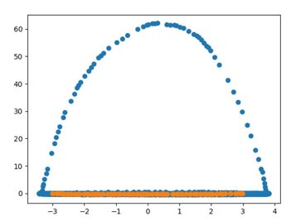
Figure 3: A gif of the evolution of points along the first component of an ADK reduction generated using diffusion map. The protein visibly contracts as the movie progresses. The points and the graph were extracted from left to right, and coloured in orange. The diffusion map graph is the same as the one seen in figure 6, but coloured differently.
As a demonstration of point extraction, we present (Fig. 3) an evolution of conformers along the first diffusion map component of a system ran on ADK illustrating that the first diffusion map component indeed corresponds to the open closed transition of ADK.
Note the vertical component of the axes is extremely thin, only a few points thick and so a similar evolution cannot be constructed along it. In such cases the application of functional inverse back mapping becomes invaluable.
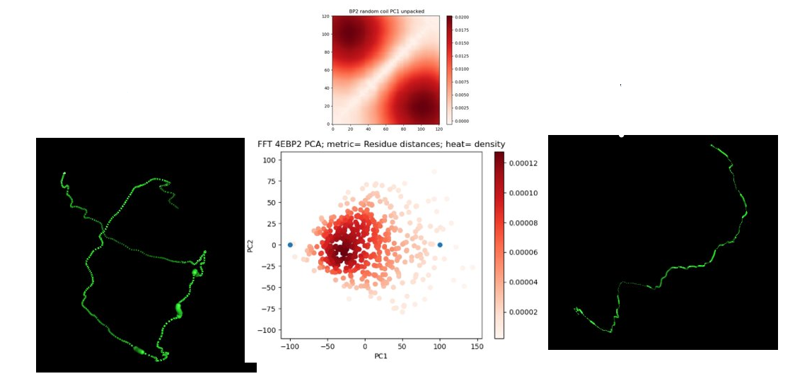
Figure 4: Demonstration of unwrapping and inter-residue back mapping. Top: Graph of the fist PCA component weights, for y < x, the heat at every point is equal to PC1[x + 121*y]. Bottom middle: PCA graph of the first and second component of the reduction of the ensemble with heat being density of points; two blue points indicate the point which were back mapped. Bottom left: The conformer whose inter-residue vector maps through PCA to the left most blue point in the middle PCA graph. Bottom right: The conformer whose inter-residue vector maps through PCA to the left most blue point in the middle PCA graph.

As a demonstration of the linear component unwrapping on PCA as well as the back-mapping from inter-residue space to functional space we demonstrate their use for the interpretation of the first component of a PCA reduction on a random coil generated ensemble. Two points were selected at opposite ends of the graph and the conformer that would map to them was generated using the scripts mentioned.

PCA
As a first step, PCA has been applied to several of the available protein ensembles; the resulting conclusion of which indicates that a general application of PCA to IDPs is infeasible. PCA has been applied to the space of inter-residue distance vectors of the following protein ensembles: a 30µs sic1 MD trajectory (a03ws force field and 180.036ps time step), a 30µs drkN-SH3 MD trajectory (a03ws force field and 1000.8ps time step), clustered conformations of 4EBP2 generated via FastFloppyTail, and 5000 random coil conformations of 4EBP2.
Invariably PCA analysis on the space of inter-residue vectors narrows in on the same specific large-scale features regardless of the data set. PCA component vector weights are nearly identical in distribution (as seen in figure 5), even across the number of residues in the peptide. The similarity between the unwrapped PCA components across several data sets indicates that PCA focusses on the same features regardless of data source. The distribution of singular values for PCA components is also nearly identical, meaning that the features PCA does focus on are not generally effective at representing features that distinguish peptides. PCA is incapable of distinguishing between random coil data and MD simulation, and FFT generated ensembles.

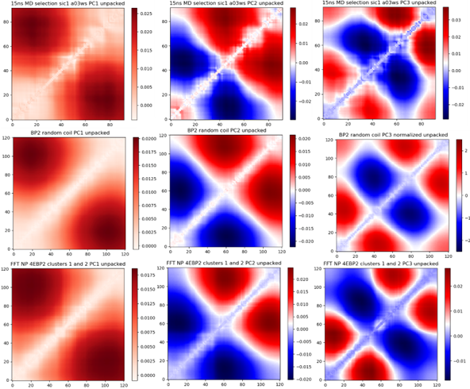
Figure 5: The values in the PCA component vectors displayed through the unwrapping. Each weight in the square corresponds to the weight the PCA component vector attaches to a specific inter-residue distance. Note the temperature scales are not identical across graphs. (a) Top row, a 30us sic1 MD trajectory sampled every 15ns. (b) Middle row, random coil ensemble. (c) Bottom row, the two most structurally distinct clusters of an NP-4EBP2 ensemble generated through FastFloppyTail

Parameters
Parameter fine-tuning in Dimensionality Reduction is a time-intensive and intricate process, marked by uncertainty regarding the optimal direction to pursue and whether improvements are indeed being achieved. The refinement of these parameters necessitates a quantifiable metric to assess the effectiveness of the reduction. In the context of paper [11], clustering was employed and assessed the fit of the clustering as their metric.
The parameters for t-Distributed Stochastic Neighbor Embedding (tSNE) include n_iter, learning_rate, perplexity, and n_components. Our tSNE implementation leveraged the sklearn.manifold package. All runs were performed with 'method' set as 'exact', 'init' as 'pca', ‘k' as 5,000, and 'metric' as the Euclidean distance between inter-residue distance.
For the ADK dataset, tSNE exhibited only subtle differences between runs on the same dataset, even when employing significantly varied perplexity or learning rate values but differed significantly with n_components.
However, a notable point of contention arises from the fact that tSNE's reduction outcomes fluctuate based on the chosen latent space dimension. Unlike diffusion maps and PCA, where the choice of components does not affect subsequent vector components (i.e., the first 4 components when reducing to 6 dimensions are the same as those when reducing to 4 dimensions), tSNE's projection is influenced by the choice of latent space dimension. This implies that the choice of dimension must be predetermined, necessitating prior knowledge or iterative refinement. While 2 or 3 dimensions are commonly employed as the latent space dimension [11], certain systems might demand more degrees of freedom for accurate representation.
A hindrance in dimensionality refinement is the absence of singular value/explained variance plots, which are available in both diffusion maps and PCA. These plots offer a way to relatively gauge the proportion of variance represented by an axis component. However, tSNE lacks this feature, and although axis order is determined by the variance they represent, the actual proportion remains elusive, rendering the quantification of the amount of reduction difficult.
Regarding Diffusion Maps, the parameters encompass epsilon, alpha, and K. The metric remained fixed as the Euclidean distance between inter-residue vectors.
Diffusion maps are notably sensitive to the selection of epsilon, yielding disparate outcomes based on this choice. Optimal epsilon varies significantly across datasets, making prior estimation challenging. The 'bgh' algorithm [13] displays potential for generating seed values of epsilon, aiding in determining the appropriate order of magnitude for the dataset.
For diffusion maps employing the Euclidean distance on inter-residue distances, alpha values less than 1 are preferable. Experiments with the alpha parameter have revealed that values <= 1 are optimal for ADK ensembles as they align the first axis component with the open-closed transition most closely. Such values of alpha assign greater importance to larger distances, emphasizing larger-scale features within proteins.

ADK closed and open transition
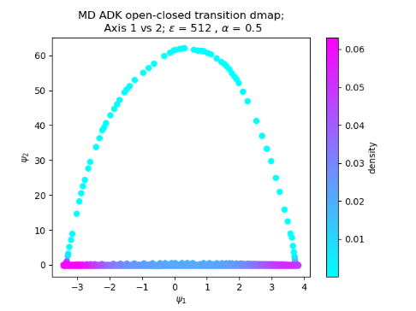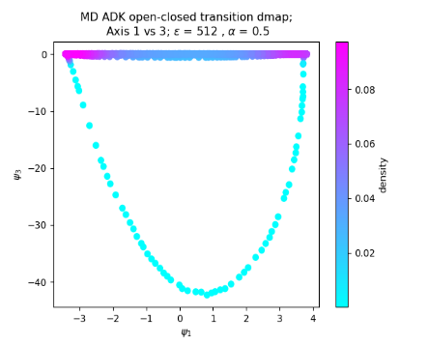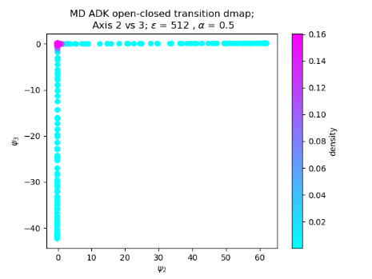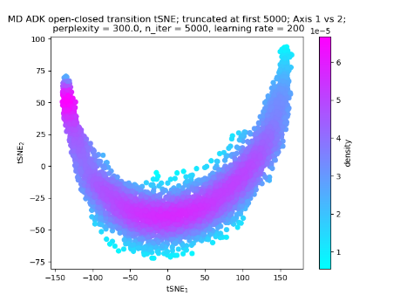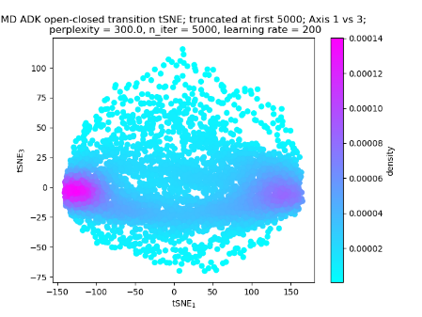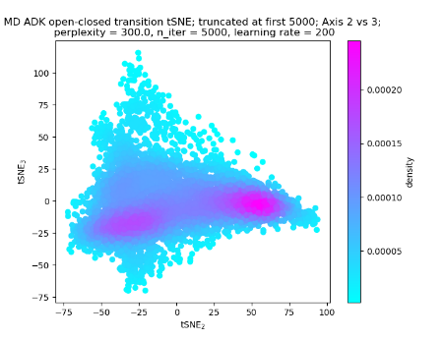
Figure 6: Diffusion map and tSNE results for the first 3,000 elements of the ADK trajectory available from X; coloured based on density. Top row: Diffusion map on data set with epsilon equal to 512, alpha equal to 0.5, from left to right: first vs second, first vs third, and second vs third components. Distinguishable in the left and middle images are two concentrated populations at opposite ends of the horizontal axis. There is a single concentrated population in the right image. Bottom row: tSNE on data set with perplexity equal to 300, n_iter equal to 5,000, and learning_rate = 200. From left to right: first vs second, first vs third, and second vs third components. Distinguishable in the images are two concentrated populations at opposite ends of the horizontal axes. Heat is density.

From figure 6 we see that both Diffusion Maps and tSNE effectively distinguished the open and closed states of ADK. By pinpointing the conformers in the dataset that correspond to points within the two populations visible at the ends of the first component (as depicted in Figure 6), it becomes evident that these conformers accurately represent the open and closed states of ADK in the dataset. Particularly noteworthy is the observation that the strand-like structures connecting the populations in the Diffusion Map results (the top row of the figure) directly correlate to sequential meta-stable states during the open-closed transition. Each strand aligns with one such trajectory, and these strands are not readily visible in the tSNE reduced space.
A distinct dissimilarity between the Diffusion Map and tSNE outcomes, as illustrated in Figure 6, pertains to the dispersion of points in the subsequent components. The lower-order components in tSNE (tSNE-2 and beyond) capture a more substantial portion of variance compared to the analogous lower-order components in Diffusion Maps (dmap-2 and beyond). This discrepancy is evident from the denser cluster of points in the tSNE reduction. Notably, the differentiation between open and closed transitions is apparent even without dimensionality reduction. Of greater interest are the subsequent components that encapsulate independent functional attributes - aspects that hold valuable potential for investigation. These transitions can provide significant insights into paths within the energy landscape, particularly the most prevalent paths traversing said landscape.
DrkNSH3 TraDES folding and unfolding
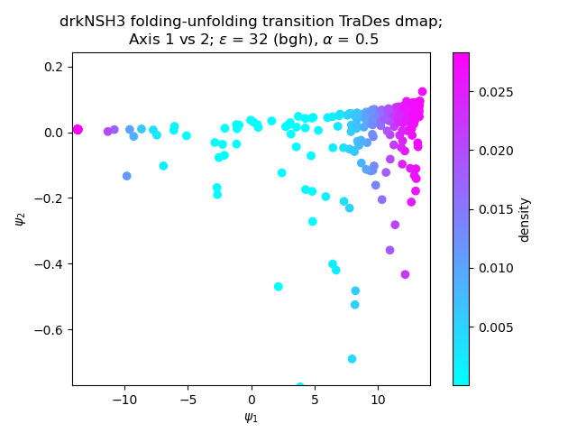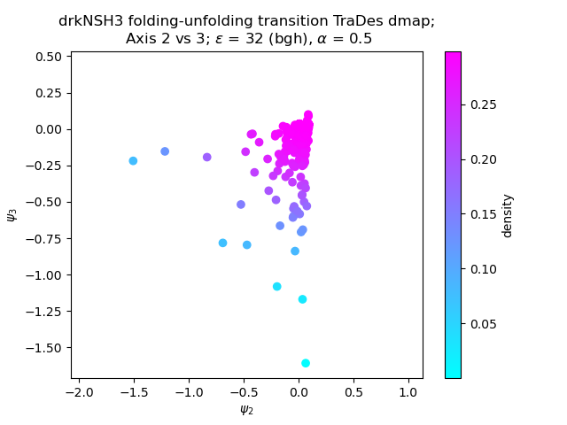
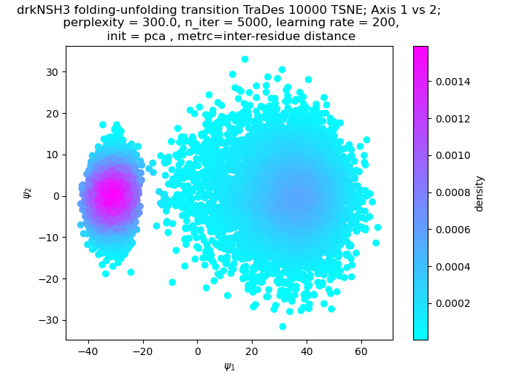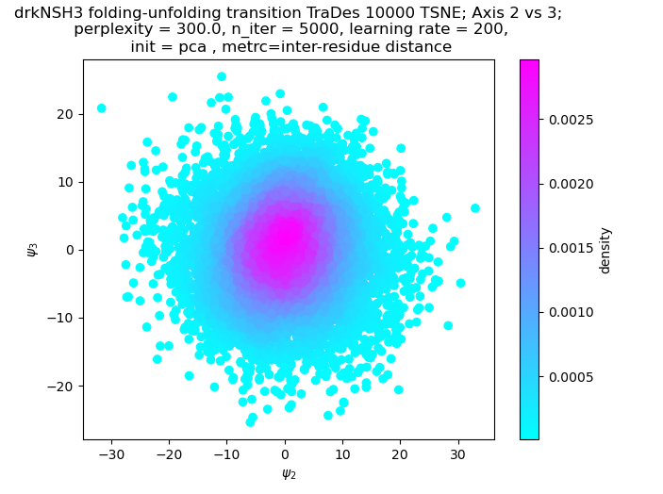
Figure 7: Diffusion map and tSNE results for a data set of 10,000 TraDES generated conformers of drkNSH3 in varying degrees of foldedness. Top row: Diffusion map on data set with epsilon equal to 512, alpha equal to 0.5; from left to right: first vs second component, second vs fourth component. In the left image a single line of points connecting two concentrated populations at opposite ends of the horizontal axis. In the right there is only a single population point. Bottom row: tSNE on data set with perplexity equal to 300, n_iter equal to 5,000, and learning_rate = 200; from left to right: first vs second component, second vs fourth component. In the left image a single line of points connecting two concentrated populations at opposite ends of the horizontal axis. In the right there is only a single population point. Heat is density.

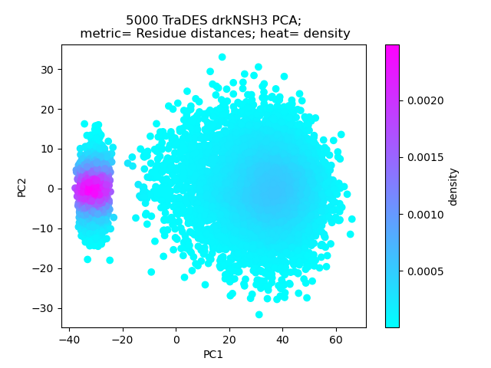
From figure 7 we see that both Diffusion Maps and tSNE effectively distinguished between the folded and unfolded states of drkNSH3. However, akin to the outcomes observed with ADK, Diffusion Maps exhibit a notably smaller portion of variance captured by the first component in comparison to the subsequent components.
Figure 12: PCA performed on the same data set as figure 7
The visual distinctions between the folded and unfolded states in the Diffusion Maps output are comparatively less pronounced, evident from the thinner lines. On the other hand, tSNE's second component, along with several other components, captures a more substantial proportion of the dataset's variance. It is worth noting the striking similarity between the outcomes of tSNE and those produced by PCA.
Furthermore, we can compare the results of tSNE on the data set from figure 7 with the results of PCA on the same data set in figure 12. The high similarity between these two graphs points to tSNE being degenerate on this system.

Mixed ensemble of 5P and NP 4EBP2
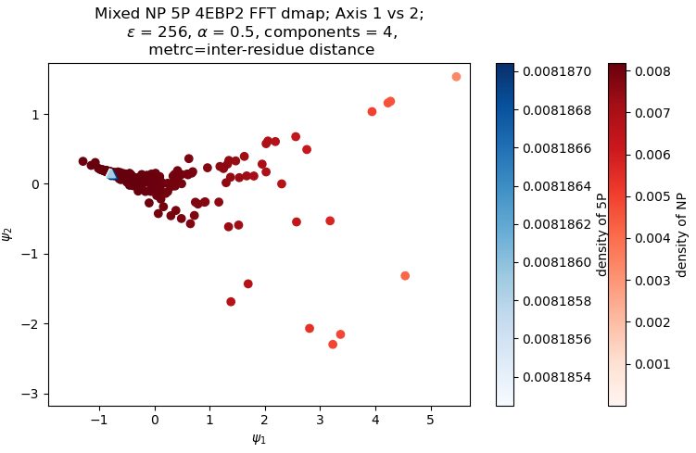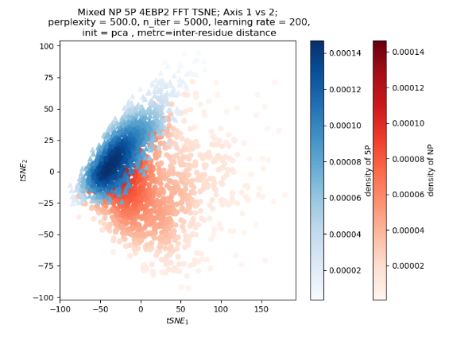
Figure 8: The first and second components of diffusion map (left) and tSNE (right) on a mixed ensemble of 1,000 conformers of 5P-4EBP2 and 1,000 conformers of NP-4EBP2 generated using FFT. Points are coloured using a heat map of density. The image of 5P conformers is in blue triangles, the image of NP conformers is red rectangles. The diffusion map graph is a cropped version of the raw data, see appendix for full graph. Heat is density.

Diffusion Maps exhibit an inability to effectively differentiate between NP and 5P conformers, as clearly depicted in figure 8. The image of 5P conformers converges to a singular point and directly overlaps with the image of numerous NP conformers. Although these conformations significantly vary from each other, the algorithm struggles to achieve a meaningful separation. In fact, the outcome of this Diffusion Map could even be considered degenerate, as all points cluster closely around a single region. It's noteworthy that the folded and unfolded states of drkNSH3, as well as the open and closed states of ADK, exhibit clear separation using Diffusion Maps. The absence of such differentiation between 5P and NP raises confusion. Presently, our explanation for this disparity revolves around the lack of intermediate conformers in the dataset. The distinctiveness of the 5P and NP conformers might result in two entirely separate clusters of points within the representation space. In the absence of intermediary points, the algorithm fails to establish any meaningful pathways between these clusters. Consequently, it yields a degenerate result, struggling to construct a manifold that adequately represents the dataset.
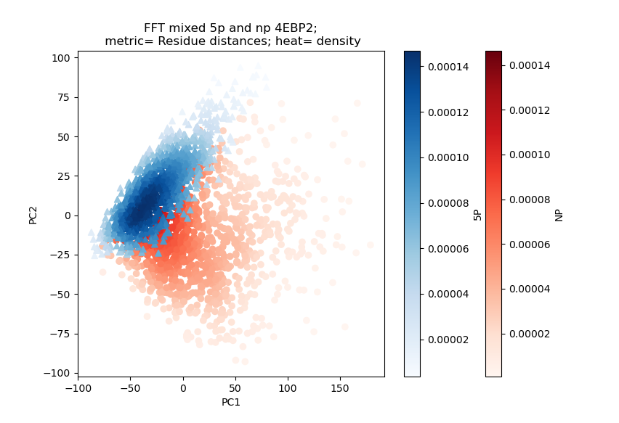
Figure 9: PCA graph of the same ensemble as figure 8, with heat as density
Shifting attention to tSNE, it initially appears adept at successfully distinguishing between NP and 5P conformers. However, it's crucial to emphasize the graph depicting the first two components of PCA applied to the same dataset (figure 9). This graph essentially mirrors the results obtained from tSNE in figure 8.

The pattern of tSNE closely resembling PCA results isn't unique to the 5P scenario. This trend is evident across all protein systems apart from ADK, in cases involving disordered proteins or regions within proteins. For instance, the 5P-4EBP2 complex is only folded across a fraction of its length. Systems featuring any form of disordered character could potentially influence the dataset's nature in a way that tSNE struggles to accommodate. The trend of tSNE having similar results to PCA is not unique to 5P, it can be observed in all protein systems outside of ADK; that is: disordered proteins or proteins with disordered regions. The 5P-4EBP2 complex is only folded at a third of its length. The system possessing any disordered character at all may affect the nature of the data in a manner that tSNE is not equipped to handle.

Dimensionality reduction on sic1
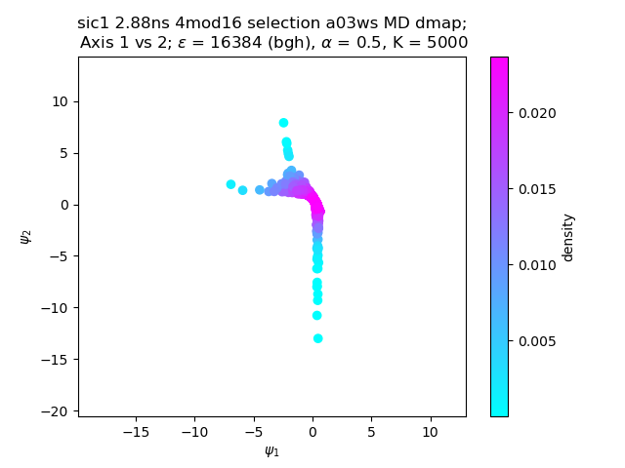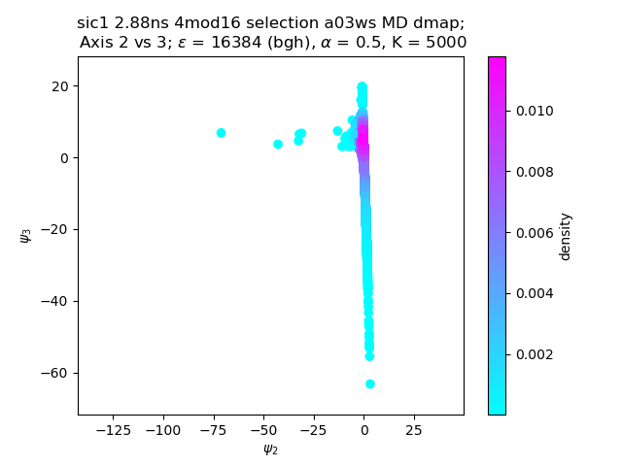
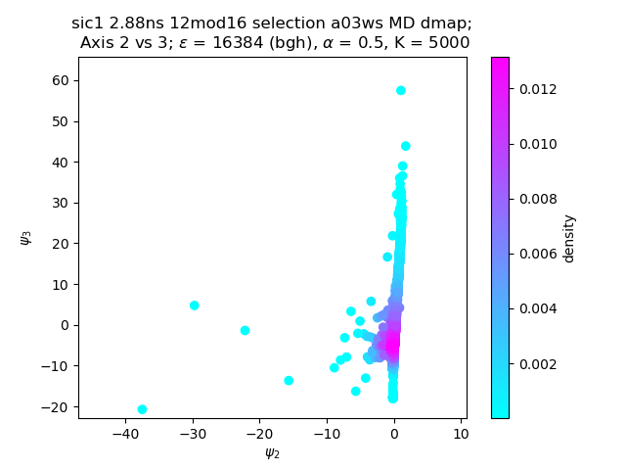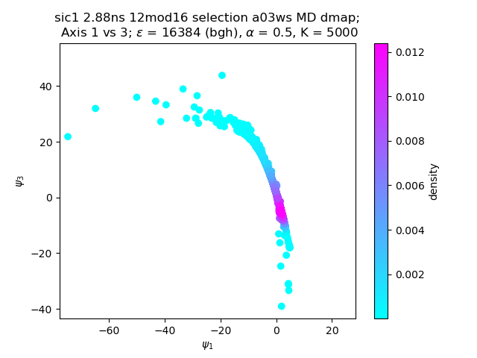
Figure 10: Cropped results of Sic1 staggered ensemble through diffusion maps (uncropped graphs included in appendix) with heat as density. Top row: frames selected whenever frame number is 4 mod 16. Bottom row: frames selected whenever frame number is 12 mod 16

When using diffusion maps, staggered selections with interval times of 0.72 ns (modulus 4) or shorter are coherent with each other. Notably, these selections match the unsampled ensemble, which represents the complete MD trajectory. Staggered selections have interval times of 2.88ns (modulus 16) or longer, consistency is not retained across different staggered ensembles. Ideally, staggered selections should belong to the same sample space and therefore remain nominally identical. The inconsistency observed in the results raises concerns.
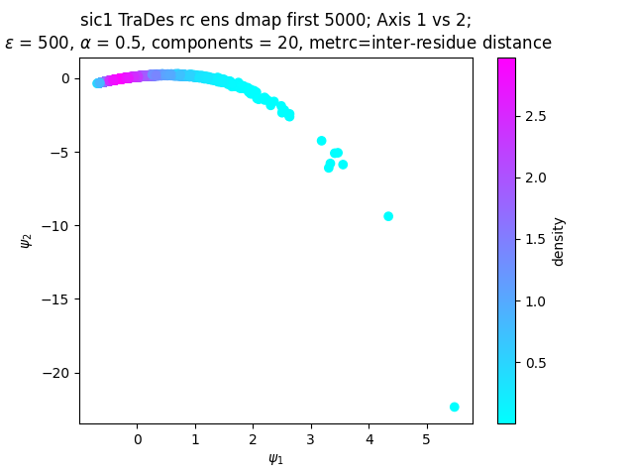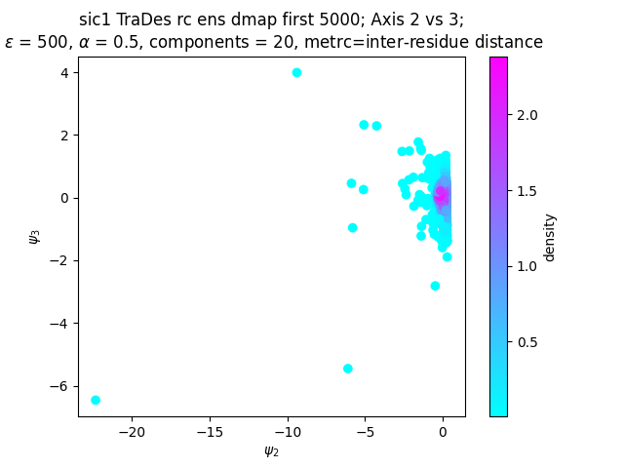
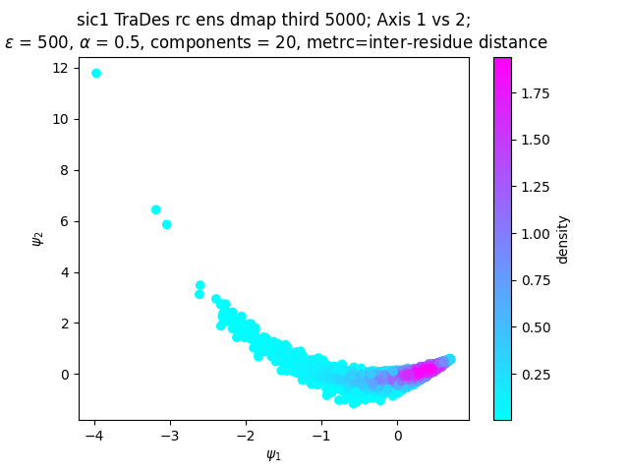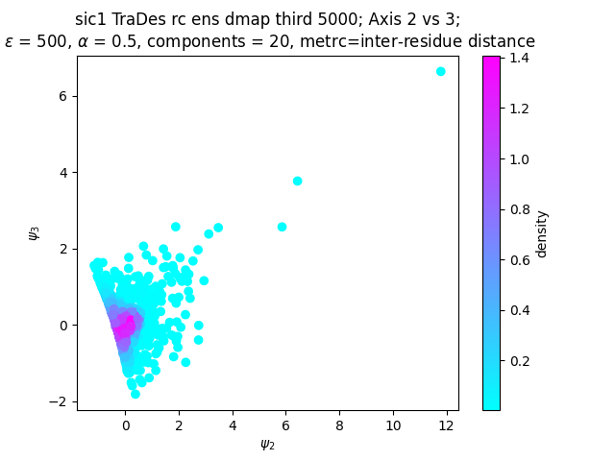
Figure 11: The first vs. second as well as second vs. third components graphed against each other for diffusion maps of TraDES generated sic1 ensembles. Top row: Diffusion map results on 5,000 TraDES generated conformers of sic1. Bottom row: Diffusion map results on another independent 5,000 TraDES generated conformers of sic1.

Ensembles generated statically on a sufficiently large scale lack time information but exhibit identical distributions while differing in composition. Utilizing diffusion maps to analyze multiple TraDES-generated ensembles of the same length offers a means to diagnose whether the inconsistencies stem from the algorithm or the dataset itself. Distinct results on datasets of similar orders generated through TraDES would indicate that diffusion maps might be overly sensitive to the dataset's composition. Consequently, diffusion maps were applied to analyze three independently generated TraDES ensembles, all with an order of 5,000. The outcomes of these analyses showed consistency as seen in fig. 11, implying that the source of inconsistency in the staggered ensembles of 2.88ns lies in the distribution rather than the size of the ensemble or the nature of the diffusion map algorithm.
The choice of 5,000 is pertinent here. This number is smaller than the staggered ensemble that exhibits divergence (which occurs at 2.88 ns or modulus 16, roughly comprising 9,700 conformers). Thus, the selection of 5,000 serves to test whether the issue arises from size or distribution. A smaller dataset theoretically presents a higher susceptibility to noise.
Collectively, the results suggest that MD trajectories do not comprehensively sample the energy landscape of an Intrinsically Disordered Protein (IDP), preventing thorough analysis. Specifically, staggered ensembles being distinct implies that MD simulations inadequately sample the energy landscape of an IDP.

Conclusions and Future Directions
In this study, we employed three distinct Dimensionality Reduction (DR) techniques to explore their applicability to a range of protein systems. Through thorough assessment, we identified the strengths and limitations of each technique, paving the way for valuable insights into potential future research directions. Principal Component Analysis (PCA) exhibited limitations in distinguishing disordered systems, while t-Distributed Stochastic Neighbor Embedding (tSNE) demonstrated promise in ordered systems like ADK and for discerning significant features like folding-unfolding in drkNSH3. However, tSNE remained unsuitable for disordered systems due to the emergence of degenerate results, echoing PCA outcomes.
Notably, Diffusion Maps displayed an inclination to yield structures even in unstructured data, indicating a challenge in reducing data to meaningful functional features. The application of back mapping emerged as a valuable tool for interpreting reductions, aiding in the identification and characterization of functional features within the reduced space. Moreover, we recognized the utility of point extraction for computational efficiency and physical conformer generation, as well as the functional inverse method for scenarios where point density was lacking.
Furthermore, our investigation revealed that Molecular Dynamics (MD) trajectories inadequately sample the conformational landscape of Intrinsically Disordered Proteins (IDPs), underscoring the importance of employing DR techniques to compensate for these limitations. Function wise strategies and the use of movies emerged as effective tools for understanding protein dynamics and evolution. Local averaging and point extraction methods were identified as valuable for pinpointing regions with minimal motion.
Moving forward it is crucial to evaluate other DR techniques alongside the comparison of their consistency. The exploration of alternative representation spaces and the quantification of reductions can aid in refining parameter tuning and enhancing the reliability of DR outcomes. In addition, future research endeavors could focus on the direct inclusion of ensemble weights into DR techniques to improve accuracy. By venturing into uncharted territories such as the inclusion of weights and exploring a wider array of DR techniques, researchers can unlock new insights, correlations, and a refined understanding of the intricate conformational landscapes in complex biological systems.

References
[1]
Dunker AK, Lawson JD, Brown CJ, Williams RM, Romero P, Oh JS, Oldfield CJ, Campen AM, Ratliff CM, Hipps KW, Ausio J, Nissen MS, Reeves R, Kang C, Kissinger CR, Bailey RW, Griswold MD, Chiu W, Garner EC, Obradovic Z (2001). "Intrinsically disordered protein". Journal of Molecular Graphics & Modelling. 19 (1): 26–59.

[2]
Uversky, Vladimir N. “Intrinsically Disordered Proteins and Their ‘Mysterious’ (Meta)Physics.” Frontiers, 17 Jan. 2019, www.frontiersin.org/articles/10.3389/fphy.2019.00010/full

[3]
Using chirality to probe the conformational dynamics and assembly of intrinsically disordered amyloid proteins - Scientific Figure on ResearchGate. Available from: https://www.researchgate.net/figure/Energy-landscapes-a-An-intrinsically-disordered-peptide-CcdA-C-terminus-Local-free_fig2_320171007 [accessed 14 Jun, 2023]

[4]
Brookes, David H., and Teresa Head-Gordon. “Experimental Inferential Structure Determination of Ensembles for Intrinsically Disordered Proteins.” ACS Publications, 11 Mar. 2016, pubs-acs-org.myaccess.library.utoronto.ca/doi/full/10.1021/jacs.6b00351.

[5]
https://librarysearch.library.utoronto.ca/discovery/fulldisplay?docid=alma991107232132306196
For some reason I can’t access the above link and I don’t remember the paper title. So, I can’t make a proper citation. Sorry about that.

[6]
“Dimensionality Reduction.” Analogicx, 3 Mar. 2022, analogicx.in/dimensionality-reduction/.

[7]
Castroverde, John, and Gregory-Neal Gomes. “Local Chain Dynamics of Intrinsically Disordered Sic1 Protein Inferred from Fluorescence Anisotropy Decay Measurements.” Biophysical Journal, 15 Feb. 2018, www.cell.com/biophysj/pdf/S0006-3495(18)32377-4.pdf.

[8]
Similarity Analysis: A Method for Quantifying Macromolecular Pathways. PLoS Comput Biol 11(10): e1004568. https://doi.org/10.1371/journal.pcbi.1004568

[9]
“Developing a Molecular Dynamics Force Field for Both Folded and ... - PNAS.” PNAS, 7 May 2018, www.pnas.org/doi/abs/10.1073/pnas.1800690115.

[10]
de la Porte, J. An Introduction to Diffusion Maps - Campus Tour, 2008, inside.mines.edu/~whereman/papers/delaPorte-Herbst-Hereman-vanderWalt-PRASA-2008.pdf.

[11]
Appadurai, Rajeswari, et al. “Demultiplexing the Heterogeneous Conformational Ensembles of Intrinsically Disordered Proteins into Structurally Similar Clusters.” bioRxiv, 1 Jan. 2022, www.biorxiv.org/content/10.1101/2022.11.11.516231v2.

[12]
Gary W. Daughdrill, Stepan Kashtanov, Amber Stancik, Shannon E. Hill, Gregory Helms, Martin Muschol, V´eronique Receveur-Br´echot, and F. Marty Ytreberg. Understanding the structural ensembles of a highly extended disordered protein. Mol. BioSyst., 8:308–319, 2 012.

Appendix

